# Inception Document

# ---- Real-time Monitoring System

## Overview (vision and business control)

The Cloud Computing technologies are getting popular and facilitating people’s live and communication. Yet it also brings many challenges to IT professionals. Connecting large numbers of computers on a single network which is known as cloud computing raises many challenges for IT professionals. Reliability and Availability are two important benchmark targets that IT managers aim for.

In order to help IT managers to monitor their computers or servers immediately and easily, our team will develop a framework of real-time monitoring system that is flexible and extendable. Comparing to quite a few traditional Monitoring System that require sitting in front of computer or getting alarm messages via email, we will use the latest technologies like Android App and Facebook Messages to develop a new monitoring system. Therefore, IT managers can monitor performance of their servers anytime and anywhere. Thus, IT managers can maximize workload throughput and enhance performance by making sure that no single processing node is overtaxed while others are underutilized. Finally, it helps IT managers to enhance Reliability and Availability.

## Functions Analysis --- Use-Case model

* Use-Case 1: Configuration. This use-case is mainly about how to configure the server side by using a Shell Utility Tool. It mainly includes 6 modules including Configure Local Server, Configure Cluster, Manage Monitoring Account, Configure Facebook Account, Check Cluster Configuration and Check Local Server Configuration. By using these 6 modules step by step, all configuration parameters will be generated and stored in a Server.config file. Thus, the server application will automatically load these running environment parameters into memory when it starts to run and initiates.

**Char 1**

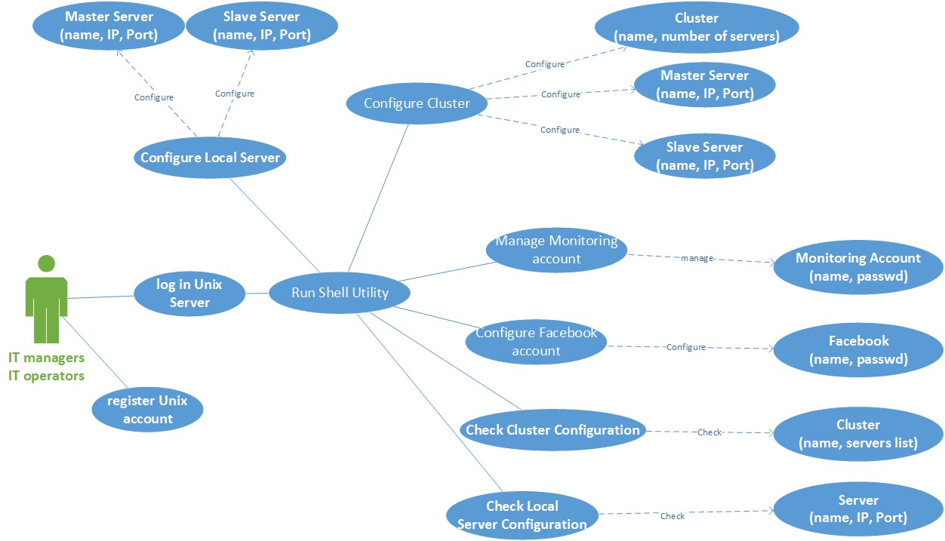

* Use-Case 2: Monitoring. This use-case show how IT managers and operators are going to monitor the workload and performance of Cluster Servers by using an Android App client. It mainly includes 5 modules including Cluster Manage, Cluster List, Server List, Check Alarm messages and Setting. By using these 5 modules, IT managers and operators can create a Cluster including serval Servers on the Android Side. After connecting to Server Application, Android App will receive data of System workload, CPU usage, Memory usage and Disk usage for this Cluster. Thus, IT managers and operators can real-time monitor workload of servers anytime and anywhere.

**Char 2**

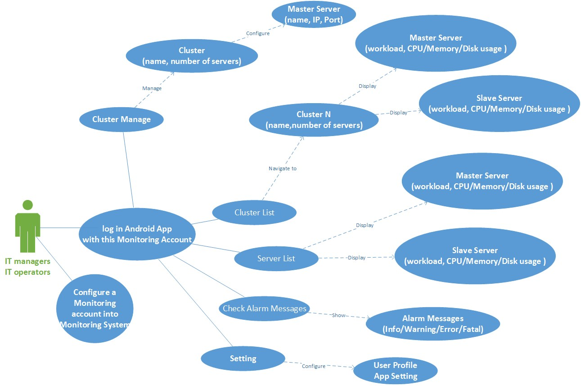

* Use-Case 3: Getting Alarm Messages via facebook. This use-case shows that IT managers and operators can get alarm messages by using facebook while they are out of work. Actually, the alarm messages which reach the level of Warning/Error/Fatal will automatically push to IT managers and operators’s facebook app by using facebook API. However, those daily log of servers will not be push to IT managers and operators.

**Char 3**

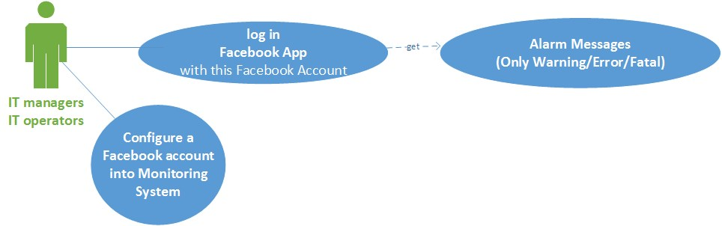

## Supplementary specification

Server logs supplement is a very important function in this system development. The log is an effective means of reflecting its workload. For the management of the log, it can be recorded locally or remotely. We prefer to the local log which is more efficient than remote log. Using server log can help us to analyze the performance problem of servers.

## Glossary

|  |  |
| --- | --- |
| **Glossary** | **Explain** |
| cluster | a grouping of a number of similar computers. |
| master | Principal server, which monitoring other servers. |
| Unix server | A computer, which base on UNIX that provides client stations with access to files and printers as shared resources to a computer network |
| Workload | One server need to deal with the whole work |
| Usage | One server/ equipment has been used |
| process control | Process control is a statistics and engineering discipline that deals with architectures, mechanisms and algorithms for maintaining the output of a specific process within a desired range. |
| socket | It is an endpoint of an inter-process communication flow across a computer network. |
| Http | Hyper Text Transport Protocol. HTTP is the foundation of data communication for the World Wide Web |
| UDP | User Datagram Protocol. |
| listening port | Programmers sending data to a particular port cannot expect another program to pick that data. For example, there is no point sending data to port 21, which is registered for the File Transfer protocol, hoping that Kerberos will pick it up, because Kerberos is listening on port 88. |
| Shell | It is a command-line interpreter that reads user input and executes commands. |
|  |  |

## Risk List and Management Plan

1. This is the first time we join the project together; we have not worked together before. We don’t know each other enough so that we must exchange information. Some of members have part-time job, and they must finish the project when they have free time.
2. Time is a high-risk problem as we figure out a complete framework for a real-time monitoring system and it will take a lot of time to implement and solve technical problems.
3. We should build a new solution differed from others so that our solution has unique value. But it is very difficult, we need to think more and do more.
4. Data transition can be reliable via TCP but it costs more bandwidth. We will use UDP/HTTP which are not so stable and reliable but suitable for internet data transition. We need to improve our algorithm, implementation method to optimize our solution based on huge amount of test. It is a huge challenge for us.
5. When we design the App, we tried to use two ways: using Android Browser to load HTML file from the server or using native Android Application to get few data and display it in a native way. We discussed that and we cannot find which one is the best for the project, and we need to do more test.
6. Android App will receive a lot of data and how to organizing and display it is a difficult problem. We want to let user easy to use. We tried some UIs just like squared paper or menu, and we will decide one based on our test later.
7. **Prototypes and proof of concepts**

|  |  |  |
| --- | --- | --- |
| Log in interface | Android App main UI | Creating a Cluster |
| C:\Users\apple\AppData\Local\Temp\WeChat Files\139940566294429913.png | C:\Users\apple\AppData\Local\Temp\WeChat Files\315915526046050789.png | C:\Users\apple\AppData\Local\Temp\WeChat Files\700441419558327563.png |
| Connecting to a Cluster | Sample1: CPU usage |  |
| C:\Users\apple\AppData\Local\Temp\WeChat Files\708608122181643054.png | C:\Users\apple\AppData\Local\Temp\WeChat Files\834087353374603755.png |  |
|  |  |  |

## Iteration Plan

In the first elaboration, we plan to realize the main functions. For the Server Application, it can monitor all the performance data of servers. It can monitor the usage of CPU, memory and storage and average workload either the master server or slave server. It can manage the account of Android and Facebook.It can also configure different clusters, IPs and ports. For the client, he can manage his account, inquire system’s usage and receive alarm massage.

In the next elaboration, we plan to implement these functions and improve the disadvantages

## Phase plan and software development plan

In phase 1, we have finished the preliminary design and figured out the main functions of this solution. In next phase, we are going to focus on developing this software including elementary implementation of some certain functions and some UI design. The languages we are going to use are C, Java, JavaScript and HTML and development tool will be Visual Studio, Eclipse and Android Studio. We will have meetings regularly to make sure everyone understands his (her) task, and improve our abilities together.

## Development Case

|  |  |  |  |  |  |
| --- | --- | --- | --- | --- | --- |
| Discipline | Artifact Iteration | Inception | Elaboration | Construction | Transaction |
| Business Modeling | Domain Model |  | S |  |  |
| Requirement | Use-case Model | S | R |  |  |
| Vision | S | R |  |  |
| Supplementary Specification | S | R |  |  |
| Glossary | S | R |  |  |
| Design | Design Model |  | S | R |  |
| SW Architecture Document |  | S |  |  |
| Data Model |  | S | R |  |
| Project Mangement | SW Development Plan | S | R | R | R |
| Testing | Test model |  | S | R | M |
| Implementation | Implementation model |  | S | R | R |
| Environment | Development case | S | R |  |  |
| S: start R: refine M: may need | | | | | |